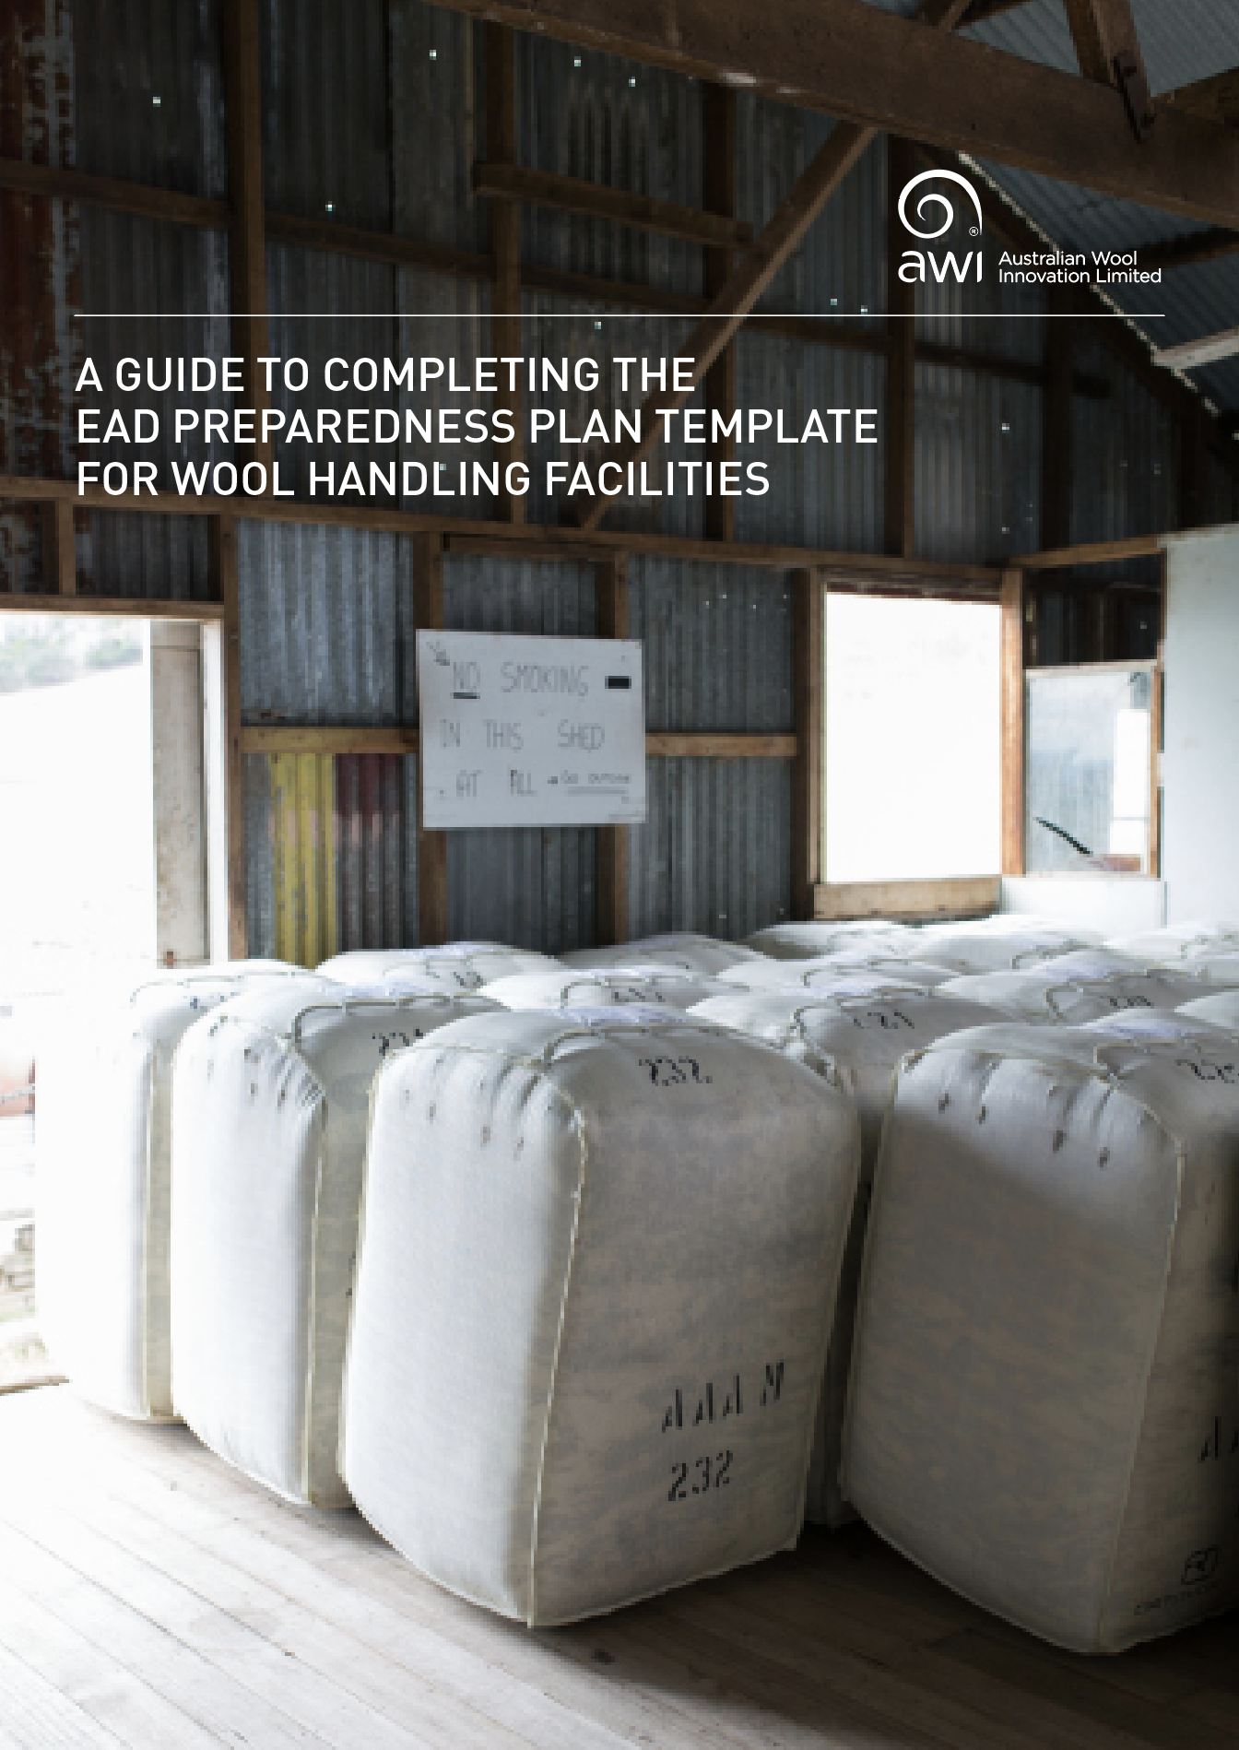

Table of Contents
INTRODUCTION 3
EAD RESOURCES 3
INFORMATION ABOUT THE BUSINESS 4
a. FACILITIES/PREMISES AND CONTACT PEOPLE 4
b. RELATED DOCUMENTATION 4
Disaster plan 4
Insurances 4
Biosecurity risk assessment 4
c. CO-LOCATED BUSINESSES 4
EAD RESPONSE 5
a. ESTABLISHING THE SITUATION 5
b. RESPONSE 5
Decontamination of wool and skins 6
Decontamination of the facility 7
Implementation of emergency response biosecurity measures 7
c. RELATIONSHIP MANAGEMENT 8
Staff support plan 8
Supplier communication plan 8
Customer communication plan 8
d. RESPONSIBILITIES 9
Appendix 1: Calculating the number of bales for isolation 10
Appendix 2: Checklist for an isolation facility 11
Appendix 3: Calculating resource requirements for decontamination 12

For more information about Emergency Animal Disease Preparedness in the Wool Industry visit https://www.wool.com/woolbiosecurity.

INTRODUCTION

If an emergency animal disease (EAD) such as foot-and-mouth disease (FMD) were to be diagnosed in Australia, there would be an immediate halt to exports of animal-related products including wool. The duration of this halt is difficult to predict and would depend on the extent of the outbreak and the causative agent but is likely to exceed six months and would expose the industry – and affected individual businesses – to significant financial risk.
Wool may become contaminated with infectious material during an EAD outbreak. Some infectious agents survive outside the host (on wool and other animal products, buildings, machines, tools, clothing and the environment) for a significant amount of time. This poses an ongoing risk for spread of the disease to susceptible stock. Facilities that have received contaminated wool will be required to comply with procedures to fully decontaminate wool and the entire facility, machines and tools as directed by the state or territory government.
The wool industry recognises the importance of EAD preparedness to minimise the risk to wool businesses. The Federation of Australian Wool Organisations (FAWO), through its EAD Working Group, is taking all feasible measures to minimise the impacts of an EAD on wool handling facilities.
A project reviewing the wool industry’s EAD preparedness recommended that all post-farm wool handling facilities should complete an EAD preparedness plan based on a FAWO-approved template. Australian Wool Innovation (AWI) has funded the preparation of this template. It provides a framework by which wool handling, processing and testing facilities can prepare for an EAD outbreak, taking into account the particular circumstances of the individual business.
Businesses that have several facilities may choose to include all the facilities in the one plan. Alternatively, a different EAD plan could be completed for each facility. If so, it is important that the interactions and movements between facilities including staff, machinery, tools and wool are accurately captured.
It is recommended that the template be completed by appropriately qualified managers and reviewed by at least one other senior staff member. The template should be reviewed every 12 months, or earlier should there be significant changes to the risk profile of the business or the industry.

EAD RESOURCES

In this section, you should identify the nearest office of your state or territory government’s department of agriculture, primary industries or similar (the department that would be responsible for managing the response to an EAD outbreak).
Identify a veterinary officer, animal health officer or biosecurity officer who can act as your ongoing point of contact on biosecurity matters. This person can assist your business to prepare your EAD preparedness plan.
Page 2 of the template (EAD Resources) provides places to record this information. You may wish to print this page and place it somewhere easily visible.

INFORMATION ABOUT THE BUSINESS

FACILITIES/PREMISES AND CONTACT PEOPLE
Record the locations and contact details for all of the facilities used by the business, whether these are owned or leased, co-located or in different locations. All premises will be affected in the event of an EAD outbreak. Having these details in one place will allow them to be quickly provided to disease management authorities when requested.

RELATED DOCUMENTATION

Disaster plan
A disaster plan or business continuity plan allows a business to plan for a massively disruptive event that is beyond its control. This might include a natural disaster, man-made event or EAD outbreak.
Disaster plan templates and action lists are available on the Australian Government’s business website.

Insurances
Businesses may consider having insurance that reduces the risk to the business of action from growers whose wool is inadvertently contaminated at the facility during an outbreak, and to mitigate the risk and consequences of failing to meet wool supply contracts due to an EAD. The latter might apply to forward-selling or contract sales to international markets or fee-for-service activities.
Some businesses will have insurance that covers interruption to trade.
Modification of contracts to include a clause covering an EAD is recommended. These might include contracts with growers, other suppliers and overseas trading partners.

Biosecurity risk assessment
Biosecurity risk assessment is an important part of EAD preparedness. A biosecurity risk assessment online app has been developed by AWI and FAWO. It can be accessed at www.wool.com/woolbiosecurity. The risk assessment does not take long to complete and will help you to identify vulnerabilities that can be addressed in advance of an EAD outbreak.
The risk assessment should be renewed at least annually to remain relevant.

CO-LOCATED BUSINESSES
Use this table to list any other businesses that are co-located within the wool business, whether or not those businesses are owned by the same company. This list may be important in the event of an EAD response to assist disease control authorities.
Business diversification can be a sound risk mitigation strategy. However, if a wool enterprise shares a facility/premises with another business, then either business may impact on the other in an EAD event. If the co-located business trades in livestock, livestock products, livestock feed or other agricultural products, it is likely that the goods in both businesses would be considered contaminated even if only one of them had received contaminated or possibly-contaminated products during an EAD or plant disease event.
If a co-located business is identified as a significant biosecurity risk, then you might consider:
- Relocating the wool or the other enterprise(s);
- Installing physical and biosecurity barriers to isolate the two businesses so that they may be considered as separate premises in the case of an EAD event (the relevant state or territory government would be responsible for making this risk assessment). This might include restrictions on movements of people, animals, machinery, tools and anything else between businesses; and
- Exploring biosecurity measures that may be taken in collaboration with the other business(es).

EAD RESPONSE

ESTABLISHING THE SITUATION
If an EAD with potential relevance to the business has been declared in Australia, you will need to engage with the available resources and authorities to keep updated on the outbreak and the likely implications for your business.
The government website www.outbreak.gov.au is a useful tool for updates. Your contact with the nearest state of territory authority will also be very important.

RESPONSE
First and foremost, you will be required to comply with any and all directions provided by the disease control authority. The response will depend upon the nature of the EAD and will evolve as the outbreak evolves.
For infectious agents that do not survive outside the host, wool plays no role in the spread of disease and there is no requirement for decontamination. However, in some cases there will still be a ban on the export of wool.
For diseases that survive outside the host there are three main scenarios for a facility that handles wool (there may be others depending on the situation). The implications of these are described below.

1. The facility is not in a Control or Restricted Area
(A Restricted Area is a legally-declared area, around premises known or suspected to be infected, in which there are strict movement controls and intense surveillance. A Control Area also has strict controls in place but these are of lesser intensity than in a Restricted Area.)
- No overseas trade;
- Controlled movement of wool onto the facility from the Control or Restricted Area (permit required);
- Access to Australian markets;
- Significant reduction in the demand for wool, therefore significant reduction in facility activities; and
- Insufficient work for staff.
2. The facility is in a Control or Restricted Area but has not received wool known or thought to be contaminated
- No overseas trade;
- Movements of wool to or from the facility require a permit issued by the appropriate government authority;
- Significant reduction in the demand for wool, therefore significant reduction in facility activities; and
- Insufficient work for staff.
3. The facility has received wool known or thought to be contaminated
- No overseas or domestic trade;
- The facility becomes an ‘infected premises’ ‘dangerous contact premises’ or ‘dangerous contact processing facility’, meaning quarantine of facility with legally-enforced movement restrictions for wool;
- No movement of wool even into isolation without a permit from the appropriate government authority;
- No normal facility activities;
- No return to trade without isolation/destruction or decontamination of wool and the facility, tools and machine etc; and
- Insufficient work for staff.
The conditions imposed on a business by an EAD response will vary depending on the causative agent (i.e. how relevant wool is to its survival and transmission, and how important the disease is to trading partners) and on the exposure of the business to the disease.
A response plan for each of the main EADs has been developed as part of AUSVETPLAN, the Australian national EAD response plan. The response will be managed by the government of the state or territory in which the disease is found.
For the majority of EADs there will be an immediate and sustained closure of overseas markets for all wool businesses regardless of their exposure to the disease or the disease agent.
Much of what you do – or do not do – during an EAD event will be dictated by the disease response authority and you will have limited discretion in many aspects. However, to assist the disease control authority and expedite your return to trade you can prepare by considering what might be required of the business during an EAD response. If the business has received or is thought to have received contaminated wool the premises will become classified as an ‘infected premises’. All wool present at the facility when the contaminated wool arrived and all the wool arriving after that time is likely to be considered contaminated.

Decontamination of wool and skins
Depending on which EAD is involved, contaminated wool will be either be disposed of by burial or burning; or it will be decontaminated by chemical treatment or isolation and storage for a defined time. The relevant state or territory government will decide on the appropriate way to deal with contaminated wool in an EAD response. It will advise you of what is required and will supervise accordingly.
In many situations, disposal of wool by burning or burial will occur on the infected premises to avoid transporting contaminated wool to a different location. The authority will direct such operations. You should consider the suitability or otherwise of your property to dispose of wool in this way. If the facility is located on a large property in a rural area, then suitable sites may be identified and recorded. Consultation with the EPA and/or state or territory government could assist in this process.
For some diseases, wool can be decontaminated by scouring. If this option was considered viable it would be managed by the authority as the wool would require transportation to an appropriate facility.
For diseases where the disease agent only survives for a short period of time, the wool may be isolated and stored until no viable disease agent remains. There are specific criteria that the storage facility must meet in order to be considered as an approved storage facility.
You should consider the options available to isolate wool should that be required. An appropriate isolation facility must be:
- An enclosed area/shed on the property that is physically isolated from the main working facility (a separate shed would be preferable to an isolated area within a shed); or
- A facility at another location (movement of bales would require a permit) where there must be no susceptible livestock.
If you have multiple facilities you may choose to ‘sacrifice’ one of these facilities, i.e. take it out of use to serve as an isolation facility for as long as required. You may choose to share a facility and isolate wool together with other wool businesses (bale identification would be crucial here).
You should consider the need for insurance for wool moved to a different location.
Detailed identification, recording and reporting on wool in isolation is crucial. Rodent, bird and feral animal movements must be managed appropriately, and these processes recorded and reassessed as required.
A table is provided in Appendix 1 to assist with calculating the number of bales that would need to be placed in isolation. Appendix 2 provides a checklist of criteria that your proposed isolation area will have to meet.

Decontamination of the facility
For many diseases agents, if your facility has received contaminated wool or skins then the whole facility and all its contents (machines, tools etc) will need to be decontaminated using a government-approved process to remove any viable infectious agent from the premises. Clear instructions will be provided by the state or territory government staff.
Whilst any required cleaning and decontamination would be done under the direction and supervision of the disease control authority, the business can plan for this in advance in order to expedite a return to trade. Appendix 3 provides a guide to determining what resources would be required should decontamination be ordered by the control authority.
In planning for the potential requirement to decontaminate, you should:
- Do a stocktake of the number and size of all buildings as well as the machinery and tools at each facility;
- Consider the types of machines, tools and facilities that would need decontamination and the materials from which they are made, as this will be important in the selection of disinfectant;
- Consider the age and condition of the tools and machines and infrastructure, as it might be more economical to dispose of items rather than decontaminating them (e.g. wool sale boxes, damaged timber structures);
- Review any SOPs or protocols the business already has for cleaning machines and tools, as these would be important to take into account if decontaminating;
- Contact the EPA to discuss the volume of waste water the facility is likely to produce during decontamination. The approval of the EPA might be required to complete this process;
- Develop a habit of removing broken or unused tools and machines so there is no unnecessary clutter in the premises;
- Maintain good hygiene in the facility reducing wool grease, dirt and dust accumulation as these will all delay decontamination. All gross dirt would need to be removed before disinfection can occur;
- Create a decontamination plan for each building within each premise; and
- Develop a log book template that could be used to record all activities.

Implementation of emergency response biosecurity measures
In the event of an EAD, and regardless of whether or not your facility is found to have contaminated wool, you will be required to implement a series of Emergency Response Biosecurity Measures (ERBM) in order to resume or continue trading. Many of these measures can be adopted as an addition to ‘business as usual’ operational activities, while others will be implemented only in the event of an EAD outbreak.
The ERBM are a series of measures that have been devised to improve biosecurity across all areas of a wool handling facility. In an EAD event these measures would need to be implemented to minimise the risk that contaminated wool is received by the business. The EBRM would form an important part of your assurance to customers that wool could be purchased safely from your business despite a previous or even ongoing EAD event.
You should review the list in Appendix 4 of the template and determine which measures the facility:
- Already complies with;
- Could easily adopt to improve biosecurity now; or
- Would need to work on further to implement in an EAD event.

RELATIONSHIP MANAGEMENT

Staff support plan
An EAD outbreak could have a devastating impact on a wool business, as the scenarios above indicate. Staff may have to be laid off or reallocated within the business. You should review current employment contracts for staff. What is the business’s legal position with regard to staff redundancies should an EAD occur?
In any case, it is important to develop a support strategy for staff that includes:
- Regular communication about the position of the business in the case of an EAD outbreak; and
- Information on support services that may be required: Lifeline, employment services, government support services.
The business should also prepare for EADs that pose a zoonotic risk, such as anthrax. Seek health professional assistance to ensure the appropriate processes and procedures can be immediately put in place to protect staff. This could include personal protective equipment, standard operating procedures and training.

Supplier communication plan
There may be several different owners of wool stored at a wool facility at any given time depending on the nature of the business. This is especially relevant where the business operates on a fee-for-service basis or acts as a broker and does not take ownership of the wool. In an EAD event, the owners of the wool will need to be informed and updated on wool market access and operational requirements such as isolation, destruction or decontamination.
It is important to:
- Maintain current, accurate and searchable records to ensure quick identification of the owners of all wool present at the facility at any time;
- Review fee-for-service and brokered wool contracts/arrangements and ensure there would be no liability for not providing the service as previously agreed; and
- Develop a communication strategy and materials for owners of the stored wool, in case of an EAD event. Useful resources might include information about the EAD outbreak and consequent cessation of trade, operational response activities of isolation / destruction / decontamination.
Other suppliers should also be kept informed as to what is happening in the business throughout an EAD event. Their goods and services will be important when business is resumed.

Customer communication plan
EAD outbreaks are chaotic experiences in which people involved in or affected by the response are extremely busy, highly stressed and under great pressure from different quarters such as the media. Information in the media on what is happening may be wildly inaccurate.
Whilst you will be subject to considerable uncertainty in your own business, your customers may be even more ‘in the dark’. It is important that you maintain the best possible communications with your customers to maximise the chances of resuming your business relationship once your business is permitted to resume trading.
You may wish to develop a draft communication document containing examples of what you might say in a live EAD situation.

RESPONSIBILITIES
For this section, determine who (individuals or positions) will be responsible for the main elements of the business’s EAD response. You may identify roles additional to those listed here.
Consider what training the identified individuals might need during ‘peacetime’ to perform the designated functions.

Appendix 1: Calculating the number of bales for isolation

The following table can be used to record the approximate number of bales that would need to be isolated. This is essential for considering facilities that would be suitable for isolation.

 | Number of standard farm bales |  | Number of other bales |  | Number of skins
Site location of wool | Busy seasons (spring) | Quiet season (winter) | Busy seasons (spring) | Quiet season (winter) | On average
Total across all facilities

Appendix 2: Checklist for an isolation facility

A facility (shed) suitable for isolating wool for the purpose of deactivating a disease agent over a period of time will need to meet the following criteria.

Criterion | Satisfied?
Not have housed infected or potentially infected livestock.
Have no susceptible livestock on the property on which the isolation area is located.
Not be another wool handing facility that is already an infected premises.
Not be directly connected in any way to the main wool handling building or any other building at the location OR the isolation can be completely physically isolated from the wool area.
Have no common/shared air flow between the isolation area and the working wool area or any other shed/facility (including draughts, heating/air-conditioning).
Be totally enclosed (roof and walls) and with closable doors and windows.
Be able to be locked up to ensure controlled access.
Have a solid floor and be free from rising damp.
Have sealed road access for vehicles.
Have an effective rodent control program in place.
Have an effective companion animal control procedure in place.
Have effective wild animal and bird controls procedures in place.

Appendix 3: Calculating resource requirements for decontamination

The following tables can be used to capture the information required to estimate the amount of disinfectant and water and number of staff required to carry out disinfection. Tables would need to be completed for each facility.
Items of machinery and equipment that may need to be on your list (the list is not exhaustive) include:
- Grab lifters
- Core samplers
- Grab samplers
- Tuft samplers
- Tuft sample reels
- Dump machines
- Dag crushers
- Decotters
- Automatic blending machines
- Containers
- Tools
- Wool classing tables
- Baling machines
Other items may include:
- Spare wool bales (new)
- Used wool bales
- Auction display boxes
- Signs, display signs
- Auctioneer stands
- Computers
- Sample bags and ties
Buildings
[Facility Name]

Building name | Floor area (LxW) | Height (H) | Total surface area (LxWxH) | Principal construction materials (walls, floors) | Is there an existing protocol for cleaning? | Condition (poor, average, excellent)
Extra areas | Floor area (LxW) | Height (H) | Total surface area (LxWxH) | Principal construction materials (walls, floors) | Is there an existing protocol for cleaning? | Condition (poor, average, excellent)
Machinery, tools and other items
Machine or tool | Number of items | Principal construction material | Is there an existing protocol for cleaning? | Condition (poor, average or excellent)
Others | Number of items | Principal construction material | Is there an existing protocol for cleaning? | Condition (poor, average or excellent)

This publication should only be used as a guide and is not a substitute for specific advice. To the extent permitted by law, we exclude all liability for loss or damage arising from the use of the information in this publication.
© 2018 Australian Wool Innovation Limited. All rights reserved. Australian Wool Innovation gratefully acknowledges the funds provided by the Australian Government to support the research, development and innovation detailed in the publication.

